Food Web Worksheet

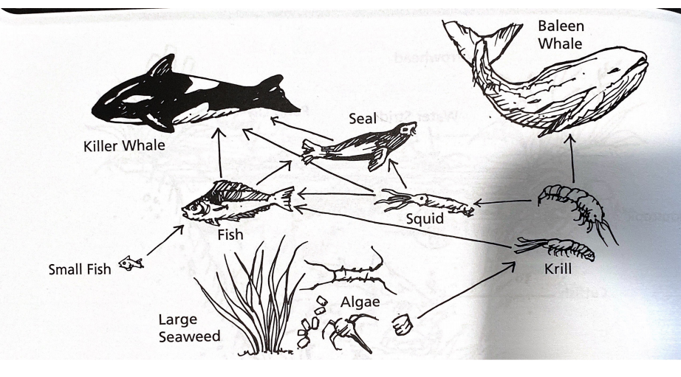

Use the food web above to answer the following questions.

1. Larger animals are known as consumers, or _the third level consumers____, because they prey on smaller animals.
2. All of the possible food chains that could be formed from the examples above would end with __algae___ , which are decomposers.
3. The microscopic algae and larger seaweeds are the _producers___ in several food chains.
4. The algae are eaten by the krill, which are eaten by squid, which are eaten by _Seal____ , which are eaten by _Killer Whales____.
5. ____Fish____ as well as ___squid_____ enjoy a favorite meal of krill.